**AIM: DESIGN A WEBPAGE TO DISPLAY THE USE OF LINQ.**

1. **Design a web page to display the employee information from table to grid control. Use LINQ to SQL  
   Build websites to demonstrate the working of entity frameworks in dot net.**

**SOURCE CODE:**

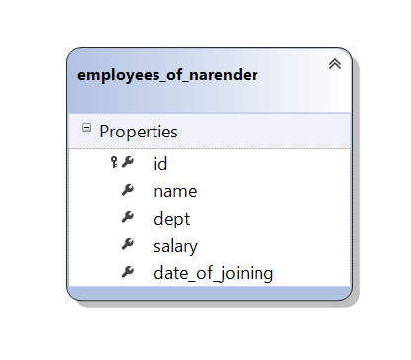

**ReadLinqToSql.aspx:**

<%@ Page Language="C#" AutoEventWireup="true" CodeFile="ReadLinqToSql.aspx.cs" Inherits="ReadLinqToSql" %>

<!DOCTYPE html>

<html xmlns="http://www.w3.org/1999/xhtml">

<head runat="server">

    <title></title>

</head>

<body>

    <form id="form1" runat="server">

        <div>

            <asp:Label ID="Label1" runat="server" Text="ID"></asp:Label>

 <asp:TextBox ID="TextBox1" runat="server"></asp:TextBox><br /><br />

 <asp:Label ID="Label2" runat="server" Text="NAME"></asp:Label>

 <asp:TextBox ID="TextBox2" runat="server"></asp:TextBox><br /><br />

 <asp:Label ID="Label3" runat="server" Text="DEPT"></asp:Label>

 <asp:TextBox ID="TextBox3" runat="server"></asp:TextBox><br /><br />

 <asp:Label ID="Label4" runat="server" Text="SALARY"></asp:Label>

 <asp:TextBox ID="TextBox4" runat="server"></asp:TextBox><br /><br />

 <asp:Label ID="Label5" runat="server" Text="DATE OF JOINING"></asp:Label>

 <asp:TextBox ID="TextBox5" runat="server"></asp:TextBox><br /><br /><br />

 <asp:Button ID="Button1" runat="server" Text="INSERT RECORD"

OnClick="Button1_Click" />

            <asp:Label ID="lblResult" runat="server" Text=""></asp:Label>

            <asp:Button ID="Button2" runat="server" Text="SHOW RECORDS"

OnClick="Button2_Click" />

            <asp:GridView ID="GridView1" runat="server">

            </asp:GridView>

        </div>

    </form>

</body>

</html>

**ReadLinqToSql.aspx.cs:**

using System;

using System.Collections.Generic;

using System.Linq;

using System.Web;

using System.Web.UI;

using System.Web.UI.WebControls;

public partial class ReadLinqToSql : System.Web.UI.Page

{

    protected void Page_Load(object sender, EventArgs e)

    {

    }

    protected void Button1_Click(object sender, EventArgs e)

    {

        using (DataClassesDataContext dc = new DataClassesDataContext())

        {

            employees_of_narender en = new employees_of_narender

            {

                id = Convert.ToInt32(TextBox1.Text),

                name = TextBox2.Text,

                dept = TextBox3.Text,

                salary = Convert.ToInt32(TextBox4.Text),

                date_of_joining = TextBox5.Text,

            };

            dc.employees_of_narenders.InsertOnSubmit(en);

            dc.SubmitChanges();

            lblResult.Text = "Successfully inserted!";

        }

    }

    protected void Button2_Click(object sender, EventArgs e)

    {

        DataClassesDataContext dc = new DataClassesDataContext();

        GridView1.DataSource = (from a in dc.employees_of_narenders select a);

        GridView1.DataBind();

    }

}

**OUTPUT:**

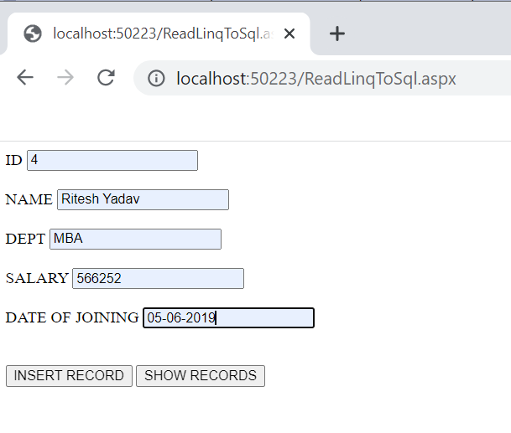

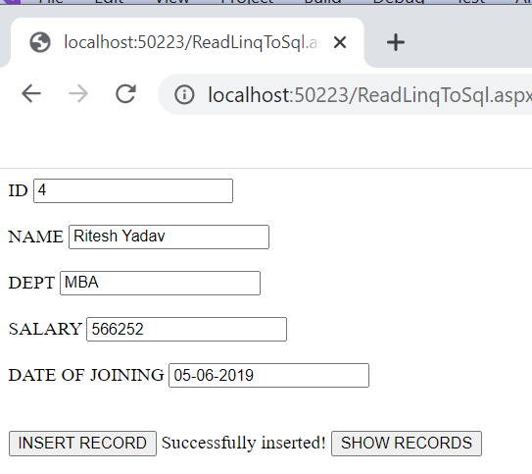

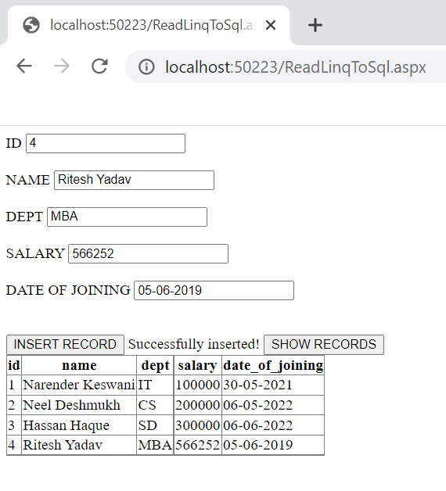

1. **Design a library system in ASP.NET and show all the book details in a Gridview dynamically using ADO.NET Entity Framework.**

**SOURCE CODE:**

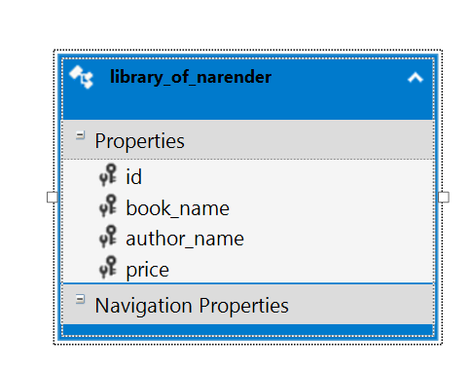

**Default3.aspx:**

<%@ Page Language="C#" AutoEventWireup="true" CodeFile="Default3.aspx.cs" Inherits="Default3" %>

<!DOCTYPE html>

<html xmlns="http://www.w3.org/1999/xhtml">

<head runat="server">

    <title></title>

</head>

<body>

    <form id="form1" runat="server">

<div>

 Enter ID to get details:

    <asp:TextBox ID="txtSrNo"

runat="server"></asp:TextBox>

 <br /><br />

 <asp:Button ID="cmdShow" runat="server" Text="Show Details"

OnClick="cmdShow_Click" />

 </div><br /><br />

 <div>

 <asp:GridView ID="GridView1" runat="server"></asp:GridView>

 <br />

 <asp:Button ID="cmdShowAll" runat="server" Text="Show All"

OnClick="cmdShowAll_Click" />

 </div>

    </form>

</body>

</html>

**Default3.aspx.cs:**

using System;

using System.Collections.Generic;

using System.Linq;

using System.Web;

using System.Web.UI;

using System.Web.UI.WebControls;

public partial class Default3 : System.Web.UI.Page

{

    protected void Page_Load(object sender, EventArgs e)

    {

    }

    protected void cmdShow_Click(object sender, EventArgs e)

    {

        int srno = Convert.ToInt32(txtSrNo.Text);

        narender_p7Entities ctx = new narender_p7Entities();

        GridView1.DataSource = (from b in ctx.library_of_narender

                                where b.id == srno

                                select b).ToList();

        GridView1.DataBind();

    }

    protected void cmdShowAll_Click(object sender, EventArgs e)

    {

        narender_p7Entities ctx = new narender_p7Entities();

        GridView1.DataSource = (from a in ctx.library_of_narender select a).ToList();

        GridView1.DataBind();

    }

}

**OUTPUT:**

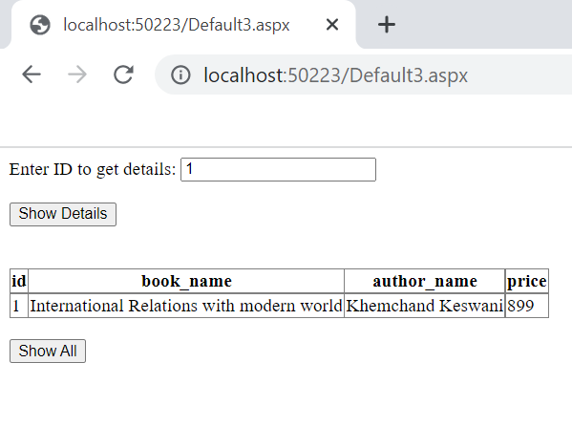

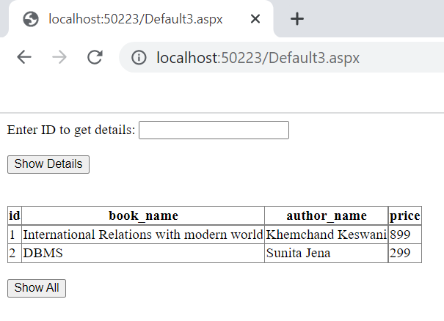

**CONCLUSION:**

From this practical, I have learned & implemented the linq to sql, ADO.NET in ASP.NET.